Article type
Article title in sentence-case capitalization
Running title: ### no more than 50 characters (spaces included) ###
Figures and Tables

Figure 1. Give title of Figure 1 and figure caption should be beneath the image.

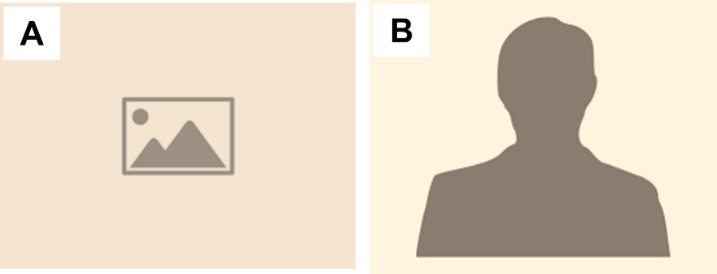
Figure 2. Title of Figure 2. (A) Give a proper title to each panel of the figure. (B) Give a proper title to each panel of the figure.

Table 1. Table caption should be placed on top of the table.
Parameters | Temperature
 | 55°C | 80°C | 100°C
Parameter A | 414 | 212 ^{b} | 313
Parameter B | 666 ª | 777 | 888
Add legend below the table. Define all abbreviations used in the table in alphabetical order and define the symbols used. ª P<0.05, ^{b} P<0.01.

Table 2. Table caption should be placed on top of the table.
Parameters | Light intensity
 | Low | Moderate | High
Parameter A | 414 | 212 ^{b} | 313
Parameter B | 666 ª | 777 | 888
Add legend below the table. Define all abbreviations used in the table in alphabetical order and define the symbols used. ª P<0.05, ^{b} P<0.01.

